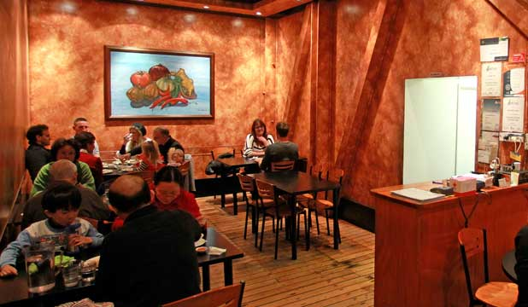**Individual Project**

**Group number: 6**

Date: 30, May 2018

Author: Andy Yang 30035616

**A Study at KK Malaysia Restaurant**

**A Well-known Local Take-away Store in Wellington CBD**

# **Individual Report**

## Andy yang (chun-an, yang) student id: 300356106

**Introduction**

KK Malaysian Restaurant is a famous local take-away place in Central Wellington at 54 Ghuznee St (Phone: 385 6698). I assumed our service unit as a M/M/2 model. Our team has done the following things for investigation: collecting customer data, getting to understand queuing situation (how the queue in this shop was formed), collecting waiting time for each service time by a customer, writing programming code to parse the data, analyzing the best-fitting distributions with Chi-Square Test, and making comparison between 3 different models that we created.

**A Description of my Activities in the Investigation**

As a contacting person between our group and the restaurant owner, first and foremost, my job was to make sure that the shop owner is happy for us to stay there and collect the customer arrival, and service time data. I need to check the shop’s occupation rate during a day and arrange the best timing that we are able to take a seat at the restaurant with our notebook or laptop while not affecting the operation of their business. This can be challenging since the restaurant has a limited capacity of only 9 tables (about 35 seats) in total to accommodate customers while the manager needs to agree that a group member as an observer will need to occupy 1 seat continuously in the service unit for at least 1 hour at a time. It took about 2 days to negotiate communally with the owner and among our group members so that eventually we decided to go for data collection during lunch time. Normally, the shop can be quite filled up at dinner time.

After collecting all data, the main burden has shifted upon me to archive and clean any errors among our recorded figures. For example, those who used monitor.py to collect data turned out to have many defectiveness. The problem was that an observer could not efficiently and accurately record every arrival’s arrival time, service beginning time, and service completion time concisely (denoted as A, B, C). Some of the customer data has missing value for service completion or beginning of service time. (e.g. No.4 Customer has only 4_A and 4_C, missing 4_B). This can result in a serious problem on the data parsing step because the array of that particular customer instance will have less index and with no value in it. As a result, I need to ‘eye-ball’ through every single line in the dataset and modify.

Next, my mission was to write two sets of Python code to read in each line of customer details and further arranged, appended the digits to several lists. From the lists, I would be able to call out the service begin time with index ‘i’ and the arrival time of that ‘i’th customer, subtract them with python datetime() function and dateDiffInSeconds() function to get the waiting time in the queue.

After data archiving process and the calculation of inter-arrival time & service time, I need to forward the results of 279 service time and about 270 data of inter-arrival time to Mingping who was in charge of analyzing the data and finding the best-fit distributions.

Besides, I am also responsible for writing the introduction for our entire group report and the formatting of the final version of our project report. Based on the information my group members gave me, it was me to make the presentation slides as well.

**What did you like/dislike during your work on the project?**

In fact, I like the part I was responsible for on the project because it was rather simple (but trivial processes). The thing was I need to be very familiar with python programming about file I/O in order to know how to parse and archive our collected data. Otherwise, without this process, data analysis would not be able to carry out smoothly and there will be no outcome values of observed E(S), W, Wq, and Ws to be compared with simulation model. After involving in this part of the project, I became more confident about my python programming skill and data management skill.

It was a great experience to help negotiate and allocate the workload of each team member. However, it would be nice if every team member can take part in every milestone to know how the model was made and study about those distributions.

**What difficulties did you have to overcome?**

1. Difficulties that lies under reading the datasets. Mostly concerning many trivial programming knowledge of python and they can be easily addressed after I had done some research online e.g. StackOverFlow.com.
2. Understanding what parameters were needed by data analysis person and do my best to provide the accurate observation result from our dataset.
3. At first, I had problem understanding how the empirical model was built but this issue was solved by reading through the handout and after a group discussion with my teammates.

**What would you do differently if you were to start the project anew?**

If I were to start this project anew, I would have participated also in the M3 empirical distribution coding part. I thought it would be very interesting to understand the background stochastic modelling concepts and apply them with python code and our realistic data.

**Any personal observations/thoughts on the setup and usefulness of the project.**

As a part time waiter at KK Malaysia restaurant for two years, it was actually a great experience and my great pleasure to do this project on my familiar place. After knowing the average time that a customer spent in a queue Wq=1.238 minutes, I could have suggested the shop to effectively streamline the queuing process and rearrange the ordering process to further minimize the waiting time a customer need to consume before he or she can order the meal. E.g. setting up a self-service order system online or a self-order machine like McDonald has.

Overall, I really enjoyed doing this project throughout the course.